Device: | 

Prepared for: | Alpha Company
AvantIQ Reference: | 05-0433-01
Product Type: | Comprehensive Device Search – Sample report
International Class(es): | 3
Goods and Services: | All goods included in the relevant class
Register(s): | United Kingdom
Completion date: | Jan 16, 2006

avantiq DISCLAIMER
All information and search reports provided by AvantIQ are for the exclusive use of the client to whom they are provided.
AvantIQ undertakes to make every effort to respect the deadline for communication of the results of the searches. Nonetheless, AvantIQ accepts no responsibility in the event of any failure to communicate or illegible or incomplete communication due to postal, telecommunications or technological services or delivery companies entrusted with the delivery of the search results.
AvantIQ’s online databases are compiled with the greatest of care and are generally accurate and comprehensive. However the information is taken from official records which are compiled and input by third parties. AvantIQ accepts no liability for the information contained therein.
The searches are handled with the utmost care. However, we cannot guarantee the completeness and accuracy of the search reports, which are subject to a number of uncertainties of a legal, technical and personal nature. The Opinions are based on the experience and knowledge of the authors but are of a largely subjective character and can only give an estimate on the legal situation and its current and future relevance for the trade marks to be searched. The Opinion cannot replace the client’s own judgement. We must therefore deny all liability for the results of the searches and the respective Opinions.
AvantIQ accepts no responsibility for delays or errors caused by force majeure, including but not limited to acts of public authorities, storms, political unrest, social disorder, computer or technological breakdowns or failures and or any negligent acts of third parties.

Content

UNITED KINGDOM TRADEMARKS 3

Abbreviations used

Pg Column title meaning “page number”
DB Column title meaning either “register”, “jurisdiction” or “country”
(A) Prefix for the application number or date
(R) Prefix for the registration number or date
(N) Prefix for the renewal date
(V) Prefix for the vulnerability date
Int.Cl. Column title and meaning “International Classes”
ET AL “and others”

How to get the most from this report.

For your convenience we have provided hyperlinks in the report. Simply put your cursor on the trademark name (in blue), push the control button (Ctrl) and click your left mouse button. You will be linked directly to the mark. If you want to get back to the overview, move your cursor on the blue trademark name, push the Ctrl button and click your left mouse button.

UNITED KINGDOM TRADEMARKS

Search strategy: | 01.05,01.07
United Kingdom
Last update: | 2005-12-18
Update information: | Updated weekly with data from the UK Patent Office.
Language(s): | English
Content of database: | National registrations, inactive, archived and pending trademarks.The database contains over 1,082,331 marks.The database contains images.Coverage: since 1876.
Remarks/  Recommendations: | It is advisable to carry out a Common Law search in the UK.For a more in-depth search on United Kingdom, it is recommended to search also for International trademarks designating United Kingdom and for European community trademarks.

Pg | Trademark | Status | App/Reg No | App/Reg Date | Classes | Goods & services | Owner
10 | Lite-Blue  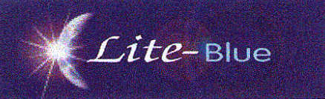 | Registered | (A) 2337391 | (R) Dec 26, 2003 | 3 | Non-medicated dermatological preparations and substances for the treatment of acne. | Photo Therapeutics Limited
12 | Lite-Red  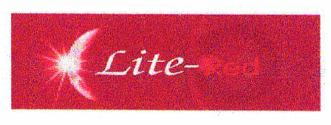 | Registered | (A) 2337392 | (R) Dec 26, 2003 | 3 | Non-medicated toilet preparations and substances; cosmetics; soaps; shampoos; dermatological prepar … | Photo Therapeutics Limited
14 | lunar  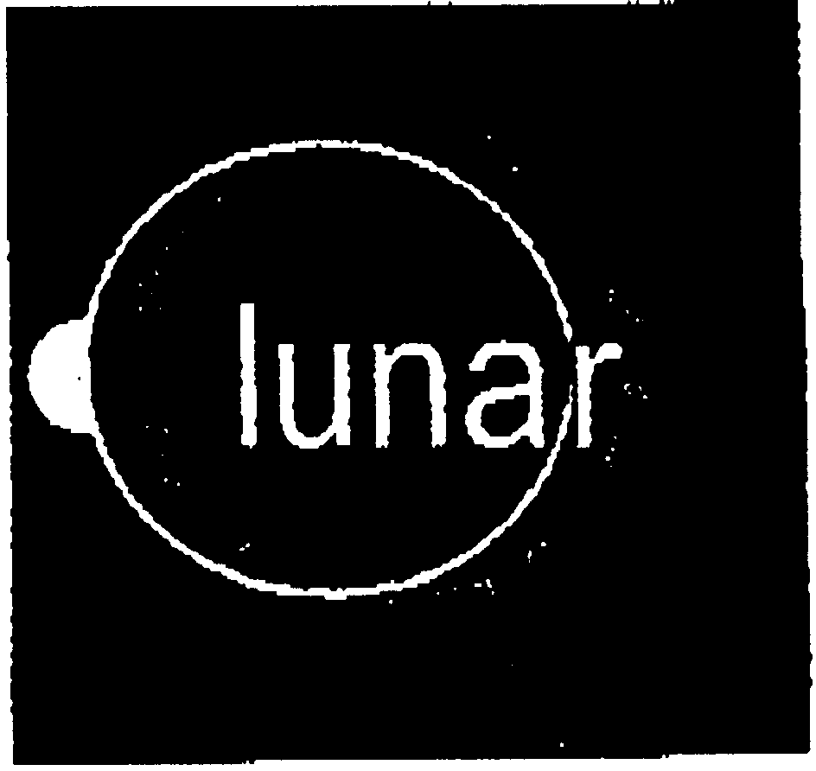 | Registered | (A) 2132428B | (R) Jul 02, 1999 | 3, 9 | Cleaning, polishing, scouring and abrasive preparations and substances; bleaches for domestic use; … | Corporate Express Limited
16 | WORLD   | Registered | (A) 2186152 | (R) Oct 22, 1999 | 24, 26, 34, 30, 8, 16, 14, 9, 33, 21, 25, 11, 18, 28, 32, 29, 3, 20, 4 | Textiles, synthetic textiles and goods made therefrom; fabrics; bed and table covers; linen; flags … | World Duty Free Europe Limited
19 | WORLD DUTY FREE   | Registered | (A) 2186154 | (R) Oct 08, 1999 | 24, 26, 34, 3, 30, 32, 29, 33, 20, 14, 28, 16, 4, 18, 25, 8, 9, 11, 21 | Textiles, synthetic textiles and goods made therefrom; fabrics; bed and table covers; linen; flags … | World Duty Free Europe Limited
22 | 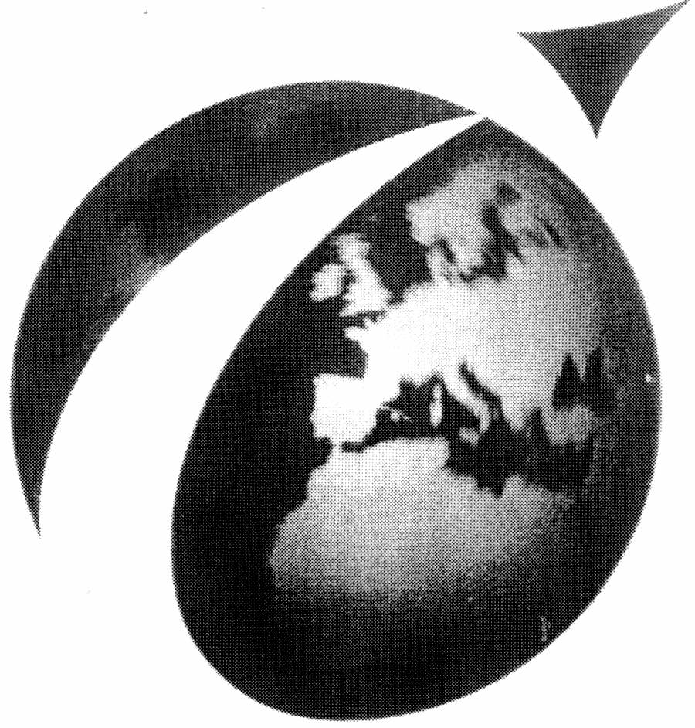 | Registered | (A) 2186146 | (R) Oct 08, 1999 | 24, 26, 28, 29, 20, 16, 30, 3, 25, 34, 32, 18, 8, 9, 21, 11, 4, 14, 33 | Textiles, synthetic textiles and goods made therefrom; fabrics; bed and table covers; linen; flags … | World Duty Free Europe Limited
25 | "Hector the Hare"  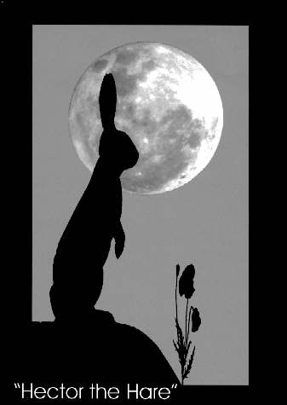 | Registered | (A) 2261136 | (R) Oct 05, 2001 | 3 | Essential oils; aromatherapy preparations for personal use including soaps, creams, lotions and bat … | Robert John Essex
27 | Fragrant Earth   | Registered | (A) 2176012 | (R) Jul 30, 1999 | 3 | Essential oils, perfumery, toiletries, cosmetics, aromatherapy products, massage oils, floral water … | Linda Kusmirek
29 | SCENT by NATURE  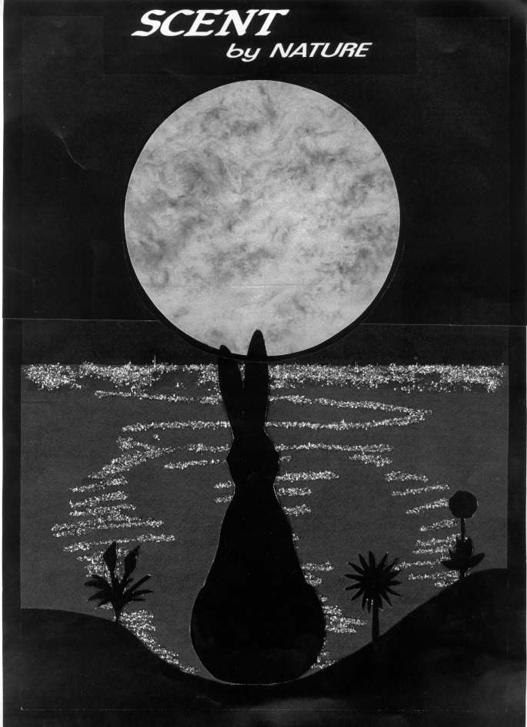 | Registered | (A) 2223832 | (R) Oct 13, 2000 | 3 | Essential oils; aromatherapy preparations for personal use including soaps, creams, lotions and bat … | Robert John Essex
31 |  | Registered | (A) 2283652A | (R) Jul 05, 2002 | 37, 29, 33, 20, 40, 31, 21, 32, 4, 3, 30 | Furniture making, maintenance and restoration services.; Meat, fish, poultry and game; meat extract … | Island 2000 Trust
34 | 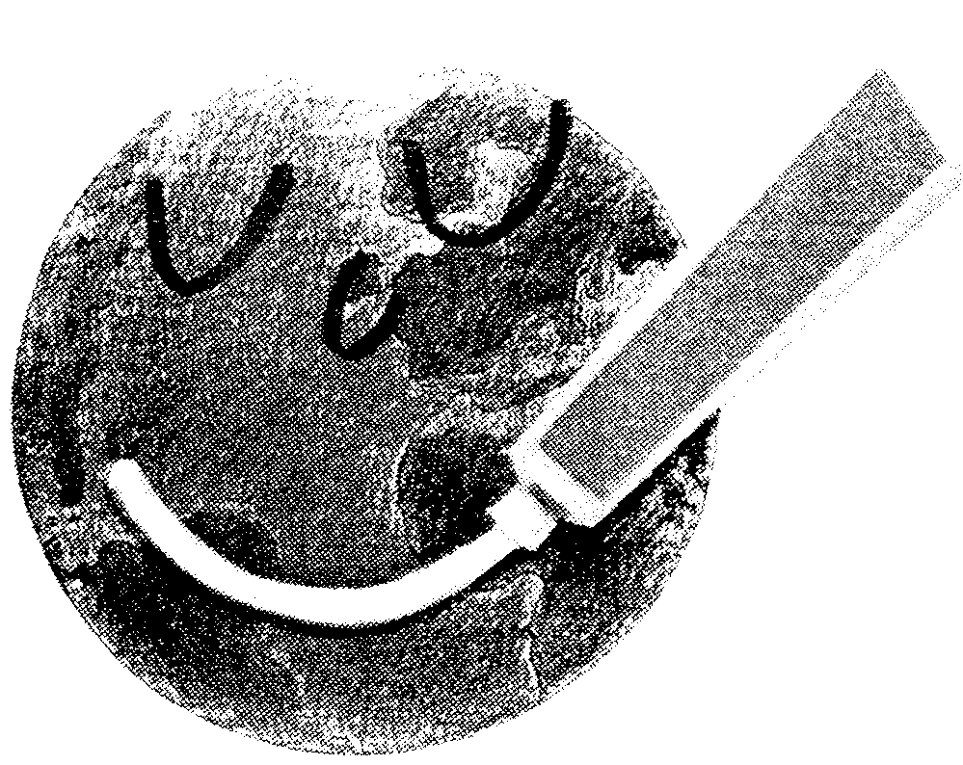 | Registered | (A) 1464406 | (R) Aug 14, 1992 | 3 | Perfumes; toilet preparations; cosmetics; dentifrices; preparations for the care of the oral cavity … | Colgate-Palmolive Company
36 | Degussa   | Registered | (A) 1060231 | (A) Mar 16, 1976 | 3 | Bleaching preparations and substances, all for laundry use; cleaning, polishing, scouring and abras … | Degussa-Hüls Aktiengesellschaft
38 | Orbomat  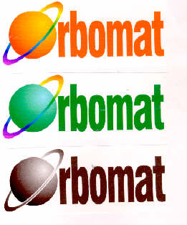 | Registered | (A) 2135178 | (R) Oct 30, 1998 | 3 | Detergents; washing powders; dishwashing powders; fabric conditioners; washing liquids. | Richmond Packaging (U.K.) Limited
40 | Orbomatic  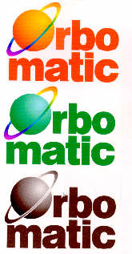 | Registered | (A) 2135179 | (R) Nov 13, 1998 | 3 | Detergents; washing powders; dishwashing powders; fabric conditioners; washing liquids. | Richmond Packaging (U.K.) Limited
42 | PLAN-IT FOR PROFIT   | Registered | (A) 2276787 | (R) Dec 13, 2002 | 3, 4, 5, 9, 11, 16, 25, 28, 29, 30, 32, 33, 34, 35 | Bleaching preparations and other substances for laundry use; cleaning, polishing, scouring and abra … | Nisa-Today's (Holdings) Limited
45 | SUNSHINE FARE   | Registered | (A) 2283652B | (R) Jul 05, 2002 | 33, 30, 40, 3, 21, 31, 32, 37, 4, 29, 20 | Cider; wine.; Flour and preparations made from cereals, bread, pastry and confectionery; cakes, sco … | Island 2000 Trust
48 | CLEAR MAGIC CONCENTRATED The Multi-Purpose Household Cleaner from Blue Coral FOR EVERY ROOM IN THE HOUSE  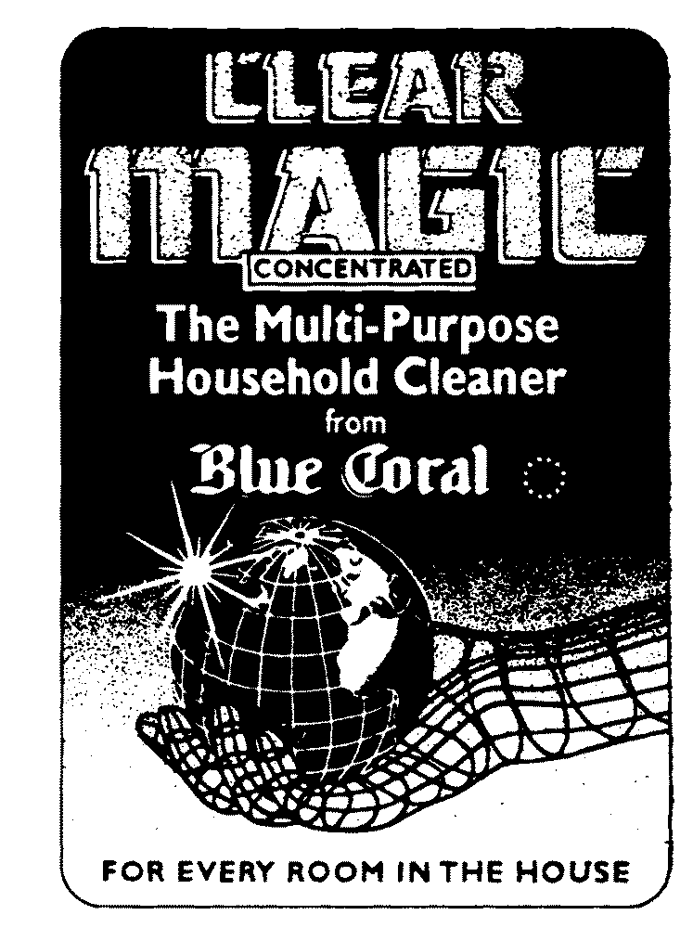 | Registered | (A) 1524293 | (R) Oct 21, 1994 | 3 | Household cleaning preparations in concentrated form, included in Class 3; but not including washin … | Pennzoil-Quaker State Company
50 | COSMICELF   | Registered | (A) 2369915 | (R) Feb 18, 2005 | 3, 14, 16, 18, 24, 25, 27, 28 | Non-medicated toilet preparations; skin care preparations; hair care preparations; cosmetics, soaps … | Cosmicelf Limited
53 | Guerlain   | Registered | (A) 1459089 | (R) May 22, 1992 | 3 | Soaps, perfumes, essential oils, cosmetics, lotions for the hair, dentifrices; non-medicated toilet … | Guerlain Societe Anonyme
55 | organic world   | Registered | (A) 2358167 | (R) Aug 13, 2004 | 3, 5, 16 | Cosmetics, toiletries, soaps, creams, lotions, oils and powders; non-medicated toilet preparations; … | Michael Stephen Eggerton
58 | PLANET herbs   | Registered | (A) 2226299 | (R) Sep 01, 2000 | 3, 5 | Cosmetics, soaps, toothpastes, mouthwashes, creams, lotions, shampoos, conditioners for hair, essen … | Phyto Medical Ltd
60 | DISTRIBUTING BRAND NAMES FROM THE WORLD TO THE WORLD · MULTIBRANDS INTERNATIONAL  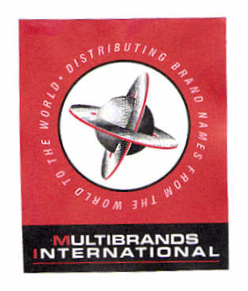 | Registered | (A) 2320467 | (R) Jul 25, 2003 | 35, 32, 3, 30, 25, 5, 34 | The bringing together, for the benefit of others, of a variety of goods, enabling customers to conv … | Multibrands International Ltd
62 | ECO FLUSH   | Registered | (A) 2137041 | (R) Mar 27, 1998 | 3, 11 | Cleaning preparations.; Cleaning agent dispensers for toilets. | Darren Tuohy & Grant Tuohy
64 | MULTIMASTER UNITERS GROUP Service Products Protection   | Advertised | (A) 2390092 | (A) Apr 21, 2005 | 2, 3, 36 | Paints, dyes, varnishes, lacquers; preservatives against rust and against deterioration of wood; co … | Uniters S.p.A.
66 | MW   | Registered | (A) 1276111 | (R) Jan 11, 1991 | 3 | Soaps, perfumes, non-medicated toilet preparations, essential oils, cosmetics, dentifrices and prep … | Miss World Limited
68 | NO WASTE LIKE HOME   | Pending | (A) 2405318 | (A) Oct 31, 2005 | 3, 8, 9, 11, 16, 18, 21, 41 | Bleaching preparations and other substances for laundry use; cleaning, polishing, scouring and abra … | Celador International Limited
71 | 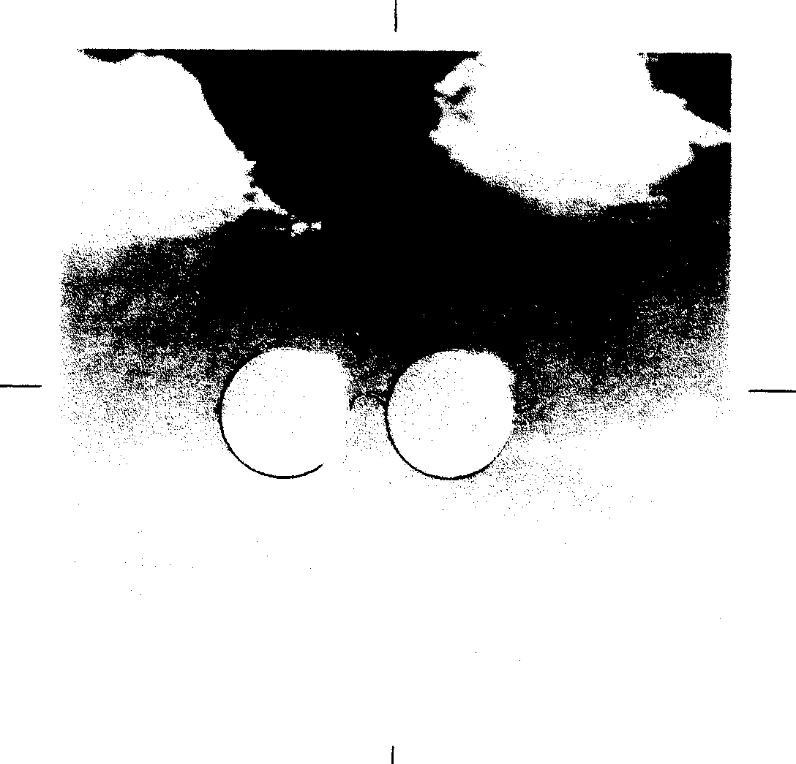 | Registered | (A) 2013933 | (R) Jan 19, 1996 | 3, 21 | Cleaning and polishing preparations, all included in Class 3.; Cloths, sponges and materials for cl … | Reckitt Benckiser (UK) Limited
73 |  | Registered | (A) 1313700 | (R) Oct 06, 1989 | 3 | Soaps included in Class 3. | BET Environmental Services PLC
75 | BOL   | Pending | (A) 2407439 | (A) Nov 10, 2005 | 3, 8, 16, 29, 30, 32 | Hygiene, cleaning aid, washing up liquid, bleach.; Disposable cutlery.; Packing, pizza boxes, take … | Rustem Ozdemir
77 | JP   | Registered | (A) 2216270 | (R) Oct 27, 2000 | 9, 21, 35, 42, 37, 41, 7, 3, 5 | Electronic fly traps.; Dispensers for cleaning and disinfecting preparations; cleaning instruments, … | JohnsonDiversey, Inc.
80 | With etheric oil MOTHER NATURE  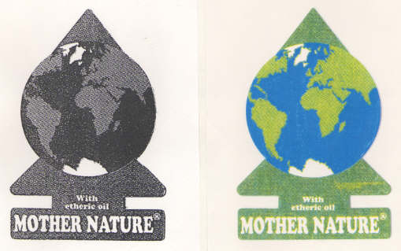 | Registered | (A) 2049786 | (R) Jun 13, 1997 | 5, 3 | Air freshening preparations; air purifying preparations; all containing etheric oil.; Essential oil … | Ralf Ehrgott

Lite-Blue | Document number  2337391, TMGB  Trademark  Lite-Blue  Appl & Reg No/Status/Dates  App no: 2337391  Status: Registered  TM Type / Description  Word-design  Classes  Int: 3  Goods and Services  Int 3: Non-medicated dermatological preparations and substances for the treatment of acne.  Vienna Code/s  01.01.01; 01.07.06  Owner  Photo Therapeutics Limited  3rd Floor  Station House  Stamford New Road  Altrincham  Cheshire  WA14 1EP  Incorporated Country: United Kingdom  Residence Country: United Kingdom  Agent  R.G.C. Jenkins & Co.  26 Caxton Street  London  SW1H 0RJ  Publication/s  Publication of application N°6497 (Sep 12, 2003)  Filing Date  Jul 11, 2003  Registration Date  Dec 26, 2003  Source Data (Update)  Nov 24, 2005 (Sep 05, 2004)  Copyright  (c) The Patent Office and IQS AvantIQ

Lite-Red | Document number  2337392, TMGB  Trademark  Lite-Red  Appl & Reg No/Status/Dates  App no: 2337392  Status: Registered  TM Type / Description  Word-design  Classes  Int: 3  Goods and Services  Int 3: Non-medicated toilet preparations and substances; cosmetics; soaps; shampoos; dermatological preparations and substances; tissues impregnated with cosmetic lotions.  Vienna Code/s  01.03.01; 01.07.06; 26.04.00  Owner  Photo Therapeutics Limited  3rd Floor  Station House  Stamford New Road  Altrincham  Cheshire  WA14 1EP  Incorporated Country: United Kingdom  Residence Country: United Kingdom  Agent  R.G.C. Jenkins & Co.  26 Caxton Street  London  SW1H 0RJ  Publication/s  Publication of application N°6497 (Sep 12, 2003)  Filing Date  Jul 11, 2003  Registration Date  Dec 26, 2003  Source Data (Update)  Nov 24, 2005 (Dec 28, 2003)  Copyright  (c) The Patent Office and IQS AvantIQ

lunar | Document number  2132428B, TMGB  Trademark  lunar  Appl & Reg No/Status/Dates  App no: 2132428B  Status: Registered  TM Type / Description  Word-design  Classes  Int: 3, 9  Goods and Services  Int 3: Cleaning, polishing, scouring and abrasive preparations and substances; bleaches for domestic use; all being for janitorial cleaning purposes.  Int 9: Optical projectors; magnetic tapes and disks, all being blank unrecorded media; batteries; all being for office use.  Vienna Code/s  01.07.01  Owner  Corporate Express Limited  Tameside Drive  Holford  Birmingham  B6 7AY  Service address: Page White & Farrer  54 Doughty Street  London  WC1N 2LS  Incorporated Country: United Kingdom  Residence Country: United Kingdom  Agent  Page White & Farrer  54 Doughty Street  London  WC1N 2LS  Publication/s  Publication of application N°6268 (Mar 17, 1999)  Filing Date  May 12, 1997  Registration Date  Jul 02, 1999  Renewal Date  May 12, 2007  Source Data (Update)  Nov 24, 2005 (Jan 23, 2005)  Copyright  (c) The Patent Office and IQS AvantIQ

WORLD | Document number  2186152, TMGB  Trademark  WORLD  Appl & Reg No/Status/Dates  App no: 2186152  Status: Registered  TM Type / Description  Word-design  Classes  Int: 24, 26, 34, 30, 8, 16, 14, 9, 33, 21, 25, 11, 18, 28, 32, 29, 3, 20, 4  Goods and Services  Int 3: Non-medicated toilet preparations; essential oils, perfumes, toilet water, fragrant preparations, fragrances; toiletries; anti-perspirants, deodorants, body sprays; talcum powder; shaving soap, shaving creams and shaving gel; aftershaves; cosmetics; preparations for the skin.  Int 4: Candles; wicks.  Int 8: Hand tools and implements; cutlery; side arms; razors; shaving implements.  Int 9: Apparatus for recording, receiving, transmitting or reproducing sound or images; records, tapes, computer disks; video tapes and cassettes; sound recordings audio tapes; data processing apparatus and computers; apparatus for use with data processing apparatus and computers; computer software; electronic games; films; cameras; video cameras; glasses and sunglasses; batteries; calculating machines; parts and fittings for all the aforesaid goods.  Int 11: Apparatus for lighting and parts for such goods.  Int 14: Precious metals and their alloys; articles made of precious or semi-precious metal or coated herewith; jewellery; precious stones; horological and chronometric instruments; clocks; watches; key rings; tie pins; parts and fittings for all the aforesaid goods.  Int 16: Printed matter; printed publications; books, magazines, journals, catalogues; stationery, writing and drawing implements; vouchers; paper serviettes, paper napkins; coasters; diaries, calendars, maps, charts; cardboard and cardboard boxes; boxes; bags and containers; packaging materials; postcards, photographs, albums; playing cards.  Int 18: Leather, imitation leather and articles made from the aforesaid materials; boxes, bags, cases, holdalls, luggage, haversacks, rucksacks, back packs, satchels, credit card holders, key holders, key fobs of leather or imitation leather, pouches, purses, wallets; umbrellas, parasols, canes, walking sticks; parts and fittings for all the aforesaid goods.  Int 20: Mirrors; picture frames; goods of wood, cork, wicker, shell, amber, mother-of-pearl, meerschaum and substitutes of all these materials, or of plastics; parts and fittings for all the aforesaid goods; wine corks.  Int 21: Small domestic utensils and containers; vessels; articles for use in storing, preparing and serving food and drink; glassware, ceramics, china, porcelain and earthenware; figurines, statuettes; decanters, drinking glasses, pipettes (wine tasters), liqueur glass sets, coolers; wine racks.  Int 24: Textiles, synthetic textiles and goods made therefrom; fabrics; bed and table covers; linen; flags and pennants.  Int 25: Clothing; footwear; headgear; parts and fittings for all the aforesaid goods.  Int 26: Badges and emblems all for wear and all made from textile materials; buttons and buckles, all being clothing, fasteners and brooches, none of precious metal or coated herewith; lace and embroidery; artificial flowers.  Int 28: Toys, games and playthings; dolls; gymnastic and sporting articles; decorations for Christmas trees and festive occasions; parts and fittings for all the aforesaid goods.  Int 29: Meat, fish, seafood, poultry and game, and food products made therefrom; meat extracts; preserved, dried, frosted, crystallised and cooked fruits and vegetables; prepared nuts; jellies; jams; dairy products; milk products; yoghurts; edible oils; preserves.  Int 30: Coffee, tea, drinking chocolate, biscuits, cookies; confectionery; honey; mustard; vinegar; sauces; condiments; spices.  Int 32: Beers; de-alcoholised beers; mineral, carbonated and aerated waters; non-alcoholic drinks; vegetable and fruit drinks and juices; syrups and other preparations for making beverages.  Int 33: Alcoholic beverages (except beers); spirits; wines; liqueurs.  Int 34: Tobacco; tobacco products; smokers' articles; lighters; matches.  Vienna Code/s  01.05.01; 26.01.00; 26.03.00  Owner  World Duty Free Europe Limited  130 Wilton Road  London  SW1V 1LQ  Incorporated Country: United Kingdom  Residence Country: United Kingdom  Agent  D. Young & Co.  120 Holborn  London  EC1N 2DY  Publication/s  Publication of application N°6284 (Jul 07, 1999)  Filing Date  Jan 12, 1999  Registration Date  Oct 22, 1999  Source Data (Update)  Nov 24, 2005 (Oct 10, 2004)  Copyright  (c) The Patent Office and IQS AvantIQ

WORLD DUTY FREE | Document number  2186154, TMGB  Trademark  WORLD DUTY FREE  Appl & Reg No/Status/Dates  App no: 2186154  Status: Registered  TM Type / Description  Word-design  Classes  Int: 24, 26, 34, 3, 30, 32, 29, 33, 20, 14, 28, 16, 4, 18, 25, 8, 9, 11, 21  Goods and Services  Int 3: Non-medicated toilet preparations; essential oils, perfumes, toilet water, fragrant preparations, fragrances; toiletries; anti-perspirants, deodorants, body sprays; talcum powder; shaving soap, shaving creams and shaving gel; aftershaves; cosmetics; preparations for the skin.  Int 4: Candles; wicks.  Int 8: Hand tools and implements; cutlery; side arms; razors; shaving implements.  Int 9: Apparatus for recording, receiving, transmitting or reproducing sound or images; records, tapes, computer disks; video tapes and cassettes; sound recordings; audio tapes; data processing apparatus and computers; apparatus for use with data processing apparatus and computers; computer software; electronic games; films; cameras; video cameras; glasses and sunglasses; batteries; calculating machines; parts and fittings for all the aforesaid goods.  Int 11: Apparatus for lighting and parts for such goods.  Int 14: Precious metals and their alloys; articles made of precious or semi-precious metal or coated herewith; jewellery; precious stones; horological and chronometric instruments; clocks; watches; key rings; tie pins; parts and fittings for all the aforesaid goods.  Int 16: Printed matter; printed publications; books, magazines, journals, catalogues; stationery, writing and drawing implements; vouchers; paper serviettes, paper napkins; coasters; diaries, calendars, maps, charts; cardboard and cardboard boxes; boxes; bags and containers; packaging materials; postcards, photographs, albums; playing cards.  Int 18: Leather, imitation leather and articles made from the aforesaid materials; boxes, bags, cases, holdalls, luggage, haversacks, rucksacks, back packs, satchels, credit card holders, key holders, key fobs of leather or imitation leather, pouches, purses, wallets; umbrellas, parasols, canes, walking sticks; parts and fittings for all the aforesaid goods.  Int 20: Furniture; mirrors; picture frames; goods of wood, cork, reed, cane, wicker, horn, bone, ivory, whalebone, shell, amber, mother-of-pearl, meerschaum and substitutes of all these materials, or of plastics; parts and fittings for all the aforesaid goods; wine corks.  Int 21: Small domestic utensils and containers; vessels; articles for use in storing, preparing and serving food and drink; glassware, ceramics, china, porcelain and earthenware; figurines, statuettes; decanters, drinking glasses, pipettes (wine tasters), liqueur glass sets, coolers; wine racks.  Int 24: Textiles, synthetic textiles and goods made therefrom; fabrics; bed and table covers; linen; flags and pennants.  Int 25: Clothing; footwear; headgear; parts and fittings for all the aforesaid goods.  Int 26: Badges and emblems all for wear and all made from textile materials; buttons and buckles, all being clothing, fasteners and brooches, none of precious metal or coated herewith; lace and embroidery; artificial flowers.  Int 28: Toys, games and playthings; dolls; gymnastic and sporting articles; decorations for Christmas trees and festive occasions; parts and fittings for all the aforesaid goods.  Int 29: Meat, fish, seafood, poultry and game, and food products made therefrom; meat extracts; preserved, dried, frosted, crystallised and cooked fruits and vegetables; prepared nuts; jellies; jams; eggs, milk, dairy products; milk and milk products; yoghurts; edible oils and fats; preserves; meals made or predominantly from the aforesaid goods.  Int 30: Coffee, tea, drinking chocolate, cocoa, sugar, rice, tapioca, sago and substitutes therefor, artificial coffee; whiteners; bakery products; pies; preparations made from cereals; breads; biscuits, cookies, cakes and pastry; confectionery; ice cream; ices; honey; mustard; vinegar; sauces; salad dressings; condiments; flavourings; spices.  Int 32: Beers; de-alcoholised beers; mineral, carbonated and aerated waters; non-alcoholic drinks; vegetable and fruit drinks and juices; syrups and other preparations for making beverages.  Int 33: Alcoholic beverages (except beers); spirits; wines; liqueurs.  Int 34: Tobacco; tobacco products; smokers' articles; lighters; matches.  Vienna Code/s  01.05.01; 26.01.00; 26.03.00  Owner  World Duty Free Europe Limited  130 Wilton Road  London  SW1V 1LQ  Incorporated Country: United Kingdom  Residence Country: United Kingdom  Agent  D. Young & Co.  120 Holborn  London  EC1N 2DY  Publication/s  Publication of application N°6282 (Jun 23, 1999)  Filing Date  Jan 12, 1999  Registration Date  Oct 08, 1999  Source Data (Update)  Nov 24, 2005 (Oct 10, 2004)  Copyright  (c) The Patent Office and IQS AvantIQ

Document number
2186146, TMGB
Appl & Reg No/Status/Dates
App no: 2186146
Status: Registered
TM Type / Description
Design
Classes
Int: 24, 26, 28, 29, 20, 16, 30, 3, 25, 34, 32, 18, 8, 9, 21, 11, 4, 14, 33
Goods and Services
Int 3: Non-medicated toilet preparations; essential oils, perfumes, toilet water, fragrant preparations, fragrances; toiletries; anti-perspirants, deodorants, body sprays; talcum powder; shaving soap, shaving creams and shaving gel; aftershaves; cosmetics; preparations for the skin.
Int 4: Candles; wicks.
Int 8: Hand tools and implements; cutlery; side arms; razors; shaving implements.
Int 9: Apparatus for recording, receiving, transmitting or reproducing sound or images; records, tapes, computer disks; video tapes and cassettes; sound recordings; audio tapes; data processing apparatus and computers; apparatus for use with data processing apparatus and computers; computer software; electronic games; films; cameras, video cameras; glasses and sunglasses; batteries; calculating machines; parts and fittings for all the aforesaid goods.
Int 11: Apparatus and installations for lighting, heating and cooking; parts and fittings for all the aforesaid goods.
Int 14: Precious metals and their alloys; articles made of precious or semi-precious metal or coated herewith; jewellery; precious stones; horological and chronometric instruments; clocks; watches; key rings; tie pins; parts and fittings for all the aforesaid goods.
Int 16: Printed matter; printed publications; books, magazines, journals, catalogues; stationery, writing and drawing implements; vouchers; paper serviettes, paper napkins; coasters; diaries, calendars, maps, charts; cardboard and cardboard boxes; boxes; bags and containers; packaging materials; postcards, photographs, albums; playing cards.
Int 18: Leather, imitation leather and articles made from the aforesaid materials; boxes, bags, cases, holdalls, luggage, haversacks, rucksacks, back packs, satchels, credit card holders, key holders, key fobs of leather or imitation leather, pouches, purses, wallets; umbrellas, parasols, canes, walking sticks; parts and fittings for all the aforesaid goods.
Int 20: Mirrors; picture frames; goods of wood, cork, wicker, shell, amber, mother-of-pearl, meerschaum and substitutes of all these materials, or of plastics; parts and fittings for all the aforesaid goods; wine corks.
Int 21: Small domestic utensils and containers; vessels; articles for use in storing, preparing and serving food and drink; glassware, ceramics, china, porcelain and earthenware; figurines, statuettes; decanters, drinking glasses, pipettes (wine tasters), liqueur glass sets, coolers; wine racks.
Int 24: Textiles, synthetic textiles and goods made therefrom; fabrics; bed and table covers; linen; flags and pennants.
Int 25: Clothing; footwear; headgear; parts and fittings for all the aforesaid goods.
Int 26: Badges and emblems all for wear and all made from textile materials; buttons and buckles, all being clothing, fasteners and brooches, none of precious metal or coated therewith; lace and embroidery; artificial flowers.
Int 28: Toys, games and playthings; dolls; gymnastic and sporting articles; decorations for Christmas trees and festive occasions; parts and fittings for all the aforesaid goods.
Int 29: Meat, fish, seafood, poultry and game, and food products made therefrom; meat extracts; preserved, dried, frosted, crystallised and cooked fruits and vegetables; prepared nuts; jellies; jams; dairy products; milk products; yoghurts; edible oils; preserves.
Int 30: Coffee, tea, drinking chocolate; biscuits, cookies, confectionery; honey; mustard; vinegar; sauces; condiments; spices.
Int 32: Beers; de-alcoholised beers; mineral, carbonated and aerated waters; non-alcoholic drinks; vegetable and fruit drinks and juices; syrups and other preparations for making beverages.
Int 33: Alcoholic beverages (except beers); spirits; wines; liqueurs.
Int 34: Tobacco; tobacco products; smokers' articles; lighters; matches.
Vienna Code/s
01.05.01; 01.17.02; 26.01.00; 26.03.00
Owner
World Duty Free Europe Limited
130 Wilton Road
London
SW1V 1LQ
Incorporated Country: United Kingdom
Residence Country: United Kingdom
Agent
D. Young & Co.
120 Holborn
London
EC1N 2DY
Publication/s
Publication of application N°6282 (Jun 23, 1999)
Filing Date
Jan 12, 1999
Registration Date
Oct 08, 1999
Source Data (Update)
Nov 24, 2005 (Oct 10, 2004)
Copyright
(c) The Patent Office and IQS AvantIQ

"Hector the Hare" | Document number  2261136, TMGB  Trademark  "Hector the Hare"  Appl & Reg No/Status/Dates  App no: 2261136  Status: Registered  TM Type / Description  Word-design  Classes  Int: 3  Goods and Services  Int 3: Essential oils; aromatherapy preparations for personal use including soaps, creams, lotions and bath products; incense; pouches filled with aromatic herbal preparations and essential oils.  Vienna Code/s  01.07.01; 03.05.01; 05.05.19  Owner  Robert John Essex  Parkers Cottage  Stokesby Road  Runham  Great Yarmouth  Norfolk  NR29 3EN  Residence Country: United Kingdom  Publication/s  Publication of application N°6384 (Jun 20, 2001)  Filing Date  Feb 13, 2001  Registration Date  Oct 05, 2001  Source Data (Update)  Nov 24, 2005 (Oct 07, 2001)  Copyright  (c) The Patent Office and IQS AvantIQ

Fragrant Earth | Document number  2176012, TMGB  Trademark  Fragrant Earth  Appl & Reg No/Status/Dates  App no: 2176012  Status: Registered  TM Type / Description  Word-design  Classes  Int: 3  Goods and Services  Int 3: Essential oils, perfumery, toiletries, cosmetics, aromatherapy products, massage oils, floral waters, soaps, flower extracts, incense.  Vienna Code/s  01.03.01; 01.05.01; 05.05.19  Owner  Linda Kusmirek  Orchard Court  Magdalene Street  Glastonbury  Somerset  BA6 9EW  Residence Country: United Kingdom  Publication/s  Publication of application N°6272 (Apr 14, 1999)  Filing Date  Aug 27, 1998  Registration Date  Jul 30, 1999  Source Data (Update)  Nov 24, 2005 (Aug 06, 1999)  Copyright  (c) The Patent Office and IQS AvantIQ

SCENT by NATURE | Document number  2223832, TMGB  Trademark  SCENT by NATURE  Appl & Reg No/Status/Dates  App no: 2223832  Status: Registered  TM Type / Description  Word-design  Classes  Int: 3  Goods and Services  Int 3: Essential oils; aromatherapy preparations for personal use including soaps, creams, lotions and bath products; incense; pouches filled with aromatic herbal preparations and essential oils.  Vienna Code/s  01.07.01; 03.05.01  Owner  Robert John Essex  Parkers Cottage  Stokesby Road  Runham  Great Yarmouth  Norfolk  NR29 3EN  Residence Country: United Kingdom  Publication/s  Publication of application N°6334 (Jun 28, 2000)  Filing Date  Feb 28, 2000  Registration Date  Oct 13, 2000  Source Data (Update)  Nov 24, 2005 (Oct 15, 2000)  Copyright  (c) The Patent Office and IQS AvantIQ

Document number
2283652A, TMGB
Appl & Reg No/Status/Dates
App no: 2283652A
Status: Registered
TM Type / Description
Design
Classes
Int: 37, 29, 33, 20, 40, 31, 21, 32, 4, 3, 30
Goods and Services
Int 3: Soaps; perfumery, essential oils, cosmetics and skin preparations.
Int 4: Candles, wicks and beeswax.
Int 20: Furniture, picture frames, goods (not included in other classes) of wood, cork, reed, cane, wicker, horn, bone, meerschaum or plastics; honeycombs.
Int 21: Glassware, porcelain and earthenware (not included in other classes); pottery; goods of terracotta and figurines.
Int 29: Meat, fish, poultry and game; meat extracts; cooked meats; meat products; poultry products; seafood and seafood products; fish products; shellfish and shellfish products; jellies, jams and chutneys; eggs; milk and milk products; dairy products.
Int 30: Flour and preparations made from cereals, bread, pastry and confectionery; cakes, scones, biscuits, savouries and pastries; ices and icecream; honey and treacle.
Int 31: Fresh fruits and vegetables; fresh and dried herbs; natural and dried flowers.
Int 32: Beers; mineral and aerated waters and other non-alcoholic drinks; fruit drinks and fruit juices.
Int 33: Cider; wine.
Int 37: Furniture making, maintenance and restoration services.
Int 40: Flour milling services; wood treatment services.
Vienna Code/s
01.03.02; 01.07.06
Owner
Island 2000 Trust
The Gatehouse
Forest Road
Newport
Isle of Wight
PO30 5YS
Incorporated Country: United Kingdom
Residence Country: United Kingdom
Agent
Prentice & Matthews
Calvert's Buildings
52B Borough High Street
London
SE1 1XN
Claim/Limit
The applicant claims the colour yellow as an element of the second mark in the series.
Publication/s
Publication of application N°6422 (Mar 20, 2002)
Filing Date
Oct 22, 2001
Registration Date
Jul 05, 2002
Source Data (Update)
Nov 24, 2005 (Jul 07, 2002)
Copyright
(c) The Patent Office and IQS AvantIQ

Document number
1464406, TMGB
Appl & Reg No/Status/Dates
App no: 1464406
Status: Registered
TM Type / Description
Design
Additional Information
Part of register: A; Section 29-1B case
Classes
Int: 3
Goods and Services
Int 3: Perfumes; toilet preparations; cosmetics; dentifrices; preparations for the care of the oral cavity, mouth and teeth; preparations for the hair; soaps; shaving preparations; toilet articles; antiperspirants and deodorants; preparations and substances for laundry and domestic purposes; cleaning preparations; polishing preparations; scouring and abrasive preparations; all included in Class 3.
Vienna Code/s
01.05.01; 04.05.02; 19.03.00
Owner
Colgate-Palmolive Company
300 Park Avenue
New York
New York 10022-7499
United States of America
Incorporated Country: United States of America (Delaware)
Residence Country: United States of America
Agent
Kilburn & Strode
20 Red Lion Street
London
WC1R 4PJ
Licensees
Mark has licensee(s)
Disclaimer
Registration of this mark shall give no right to the exclusive use of the device of a tube.
Publication/s
Publication of application N°5927 (Jun 10, 1992)
Filing Date
May 16, 1991
Registration Date
Aug 14, 1992
Source Data (Update)
Nov 24, 2005 (Mar 05, 1999)
Copyright
(c) The Patent Office and IQS AvantIQ

Degussa | Document number  1060231, TMGB  Trademark  Degussa  Appl & Reg No/Status/Dates  App no: 1060231  Status: Registered  TM Type / Description  Word-design  Additional Information  Part of register: A  Classes  Int: 3  Goods and Services  Int 3: Bleaching preparations and substances, all for laundry use; cleaning, polishing, scouring and abrasive preparations; soaps, perfumes, and non-medicated toilet preparations; essential oils, cosmetics, hair lotions and dentifrices.  Vienna Code/s  01.03.02; 01.07.06; 26.04.00  Owner  Degussa-Hüls Aktiengesellschaft  Weibfrauenstrabe 9  D-60287 Frankfurt  Germany  Service address: Elkington and Fife LLP  Prospect House  8 Pembroke Road  Sevenoaks  Kent  TN13 1XR  Incorporated Country: Germany  Residence Country: Germany  Agent  Elkington and Fife  Prospect House  8 Pembroke Road  Sevenoaks  Kent  TN13 1XR  Publication/s  Publication of application N°5193 (Mar 08, 1978)  Filing Date  Mar 16, 1976  Source Data (Update)  Nov 24, 2005 (Jun 06, 2004)  Copyright  (c) The Patent Office and IQS AvantIQ

Orbomat | Document number  2135178, TMGB  Trademark  Orbomat  Appl & Reg No/Status/Dates  App no: 2135178  Status: Registered  TM Type / Description  Word-design  Classes  Int: 3  Goods and Services  Int 3: Detergents; washing powders; dishwashing powders; fabric conditioners; washing liquids.  Vienna Code/s  01.05.24  Owner  Richmond Packaging (U.K.) Limited  New Road Winsford  Cheshire  CW7 2NY  Service address: William A. Shepherd & Son  3rd Floor  11 St. James's Square  Manchester  M2 6DN  Incorporated Country: United Kingdom  Residence Country: United Kingdom  Agent  William A. Shepherd & Son  3rd Floor  11 St. James's Square  Manchester  M2 6DR  Claim/Limit  The applicant claims the colours red, orange, yellow, blue, purple, pink and green as an element of the first Mark in the series. The applicant claims the colours green, red, orange, yellow, blue, purple and pink as an element of second Mark in the series.  Publication/s  Publication of application N°6234 (Jul 15, 1998)  Filing Date  Jun 09, 1997  Registration Date  Oct 30, 1998  Source Data (Update)  Nov 24, 2005 (Nov 28, 2004)  Copyright  (c) The Patent Office and IQS AvantIQ

Orbomatic | Document number  2135179, TMGB  Trademark  Orbomatic  Appl & Reg No/Status/Dates  App no: 2135179  Status: Registered  TM Type / Description  Word-design  Classes  Int: 3  Goods and Services  Int 3: Detergents; washing powders; dishwashing powders; fabric conditioners; washing liquids.  Vienna Code/s  01.05.24  Owner  Richmond Packaging (U.K.) Limited  New Road Winsford  Cheshire  CW7 2NY  Service address: William A. Shepherd & Son  3rd Floor  11 St. James's Square  Manchester  M2 6DN  Incorporated Country: United Kingdom  Residence Country: United Kingdom  Agent  William A. Shepherd & Son  3rd Floor  11 St. James's Square  Manchester  M2 6DR  Claim/Limit  The applicant claims the colours red, orange, yellow, blue, purple, pink and green as an element of the first Mark in the series. The applicant claims the colours green, red, orange, yellow, blue, purple and pink as an element of second Mark in the series.  Publication/s  Publication of application N°6236 (Jul 29, 1998)  Filing Date  Jun 09, 1997  Registration Date  Nov 13, 1998  Source Data (Update)  Nov 24, 2005 (Nov 28, 2004)  Copyright  (c) The Patent Office and IQS AvantIQ

PLAN-IT FOR PROFIT | Document number  2276787, TMGB  Trademark  PLAN-IT FOR PROFIT  Appl & Reg No/Status/Dates  App no: 2276787  Status: Registered  TM Type / Description  Word-design  Classes  Int: 3, 4, 5, 9, 11, 16, 25, 28, 29, 30, 32, 33, 34, 35  Goods and Services  Int 3: Bleaching preparations and other substances for laundry use; cleaning, polishing, scouring and abrasive preparations; soaps; perfumery, essential oils, cosmetics, hair lotions; dentifrices.  Int 4: Industrial oils and greases; lubricants; dust absorbing, wetting and binding compositions; fuels (including motor spirit) and illuminants; candles, wicks.  Int 5: Pharmaceutical, veterinary and sanitary preparations; dietetic substances adapted for medical use, food for babies; plasters, materials for dressings; material for stopping teeth, dental wax; disinfectants; preparations for destroying vermin; fungicides, herbicides.  Int 9: Scientific, nautical, surveying, photographic, cinematographic, optical, weighing, measuring, signalling, checking (supervision), life-saving and teaching apparatus and instruments; apparatus for recording, transmission or reproduction of sound or images; magnetic data carriers, recording discs; automatic vending machines and mechanisms for coin-operated apparatus; cash registers, calculating machines, data processing equipment and computers; fire-extinguishing apparatus.  Int 11: Apparatus for lighting, heating, steam generating, cooking, refrigerating, drying, ventilating, water supply and sanitary purposes.  Int 16: Paper, cardboard and goods made from these materials, not included in other classes; printed matter; bookbinding material; photographs; stationery; adhesives for stationery or household purposes; artists' materials; paint brushes; typewriters and office requisites (except furniture); instructional and teaching material (except apparatus); plastic materials for packaging (not included in other classes); playing cards; printer's type; printing blocks.  Int 25: Clothing, footwear, headgear.  Int 28: Games and playthings; gymnastic and sporting articles not included in other classes; decorations for Christmas trees.  Int 29: Meat, fish, poultry and game; meat extract; preserved, dried and cooked fruits and vegetables; jellies, jams, fruit sauces; eggs, milk and milk products; edible oils and fats.  Int 30: Coffee, tea, cocoa, sugar, rice, tapioca, sago, artificial coffee; flour and preparations made from cereals, bread, pastry and confectionery, ices; honey, treacle; yeast, baking-powder; salt, mustard; vinegar, sauces (condiments); spices; ice.  Int 32: Beers; mineral and aerated waters and other non-alcoholic drinks; fruit drinks and fruit juices; syrups and other preparations for making beverages.  Int 33: Alcoholic beverages (except beers).  Int 34: Tobacco; smokers' articles; matches.  Int 35: Advertising; business management; business administration; office functions.  Vienna Code/s  01.05.01  Owner  Nisa-Today's (Holdings) Limited  Park Farm Road  Foxhills Industrial Park  Scunthorpe  North Lincolnshire  DN15 8QP  Service address: Haseltine Lake  Redcliff Quay  120 Redcliff Street  Bristol  BS1 6HU  Incorporated Country: United Kingdom  Residence Country: United Kingdom  Agent  Haseltine Lake  Redcliff Quay  120 Redcliff Street  Bristol  BS1 6HU  Claim/Limit  The applicant claims the colours blue, red, purple and white as an element of the first and third marks in the series.  Publication/s  Publication of application N°6445 (Aug 28, 2002)  Filing Date  Aug 01, 2001  Registration Date  Dec 13, 2002  Source Data (Update)  Nov 24, 2005 (Nov 28, 2004)  Copyright  (c) The Patent Office and IQS AvantIQ

SUNSHINE FARE | Document number  2283652B, TMGB  Trademark  SUNSHINE FARE  Appl & Reg No/Status/Dates  App no: 2283652B  Status: Registered  TM Type / Description  Word-design  Classes  Int: 33, 30, 40, 3, 21, 31, 32, 37, 4, 29, 20  Goods and Services  Int 3: Soaps; perfumery, essential oils, cosmetics and skin preparations.  Int 4: Candles, wicks and beeswax.  Int 20: Furniture, picture frames, goods (not included in other classes) of wood, cork, reed, cane, wicker, horn, bone, meerschaum or plastics; honeycombs.  Int 21: Glassware, porcelain and earthenware (not included in other classes); pottery; goods of terracotta and figurines.  Int 29: Meat, fish, poultry and game; meat extracts; cooked meats; meat products; poultry products; seafood and seafood products; fish products; shellfish and shellfish products; jellies, jams and chutneys; eggs; milk and milk products; dairy products.  Int 30: Flour and preparations made from cereals, bread, pastry and confectionery; cakes, scones, biscuits, savouries and pastries; ices and icecream; honey and treacle.  Int 31: Fresh fruits and vegetables; fresh and dried herbs; natural and dried flowers.  Int 32: Beers; mineral and aerated waters and other non-alcoholic drinks; fruit drinks and fruit juices.  Int 33: Cider; wine.  Int 37: Furniture making, maintenance and restoration services.  Int 40: Flour milling services; wood treatment services.  Vienna Code/s  01.03.02; 01.07.06  Owner  Island 2000 Trust  The Gatehouse  Forest Road  Newport  Isle of Wight  PO30 5YS  Incorporated Country: United Kingdom  Residence Country: United Kingdom  Agent  Prentice & Matthews  Calvert's Buildings  52B Borough High Street  London  SE1 1XN  Claim/Limit  The applicant claims the colours yellow and blue as an element of the second mark in the series.  Publication/s  Publication of application N°6422 (Mar 20, 2002)  Filing Date  Oct 22, 2001  Registration Date  Jul 05, 2002  Source Data (Update)  Nov 24, 2005 (Jul 07, 2002)  Copyright  (c) The Patent Office and IQS AvantIQ

CLEAR MAGIC CONCENTRATED The Multi-Purpose Household Cleaner from Blue Coral FOR EVERY ROOM IN THE HOUSE | Document number  1524293, TMGB  Trademark  CLEAR MAGIC CONCENTRATED The Multi-Purpose Household Cleaner from Blue Coral FOR EVERY ROOM IN THE HOUSE  Appl & Reg No/Status/Dates  App no: 1524293  Status: Registered  TM Type / Description  Word-design  Additional Information  Part of register: B  Classes  Int: 3  Goods and Services  Int 3: Household cleaning preparations in concentrated form, included in Class 3; but not including washing and laundry detergents for fabrics and not including fabric conditioners, non-medicated toilet preparations or toilet soaps.  Vienna Code/s  01.05.01; 02.09.14; 25.01.00  Owner  Pennzoil-Quaker State Company  700 Milam  Texas 77002  United States of America  Service address: Shell International Limited Intellectual Property Services  P.O. Box 662  London  SE1 7NE  Incorporated Country: United States of America (Delaware)  Residence Country: United States of America  Agent  Shell International Limited Intellectual Property Services  P.O. Box 662  London  SE1 7NE  Disclaimer  Registration of this mark shall give no right to the exclusive use, separately, of the words "Clear" and "Magic" and no right to the exclusive use of the words "Concentrated", "The Multipurpose Household Cleaner" and "For Every Room In The House".  Publication/s  Publication of application N°6039 (Aug 24, 1994)  Filing Date  Jan 19, 1993  Registration Date  Oct 21, 1994  Source Data (Update)  Nov 24, 2005 (Nov 09, 2003)  Copyright  (c) The Patent Office and IQS AvantIQ

COSMICELF | Document number  2369915, TMGB  Trademark  COSMICELF  Appl & Reg No/Status/Dates  App no: 2369915  Status: Registered  TM Type / Description  Word-design  Classes  Int: 3, 14, 16, 18, 24, 25, 27, 28  Goods and Services  Int 3: Non-medicated toilet preparations; skin care preparations; hair care preparations; cosmetics, soaps, perfumes, essential oils, fragrances.  Int 14: Jewellery; bracelets, brooches, jewellery pins; jewellery chains; rings, toe rings, toe gems, anklets, charms, lockets, pendants, earrings, necklaces, buckles, tie clips, tie pins, cufflinks, key rings, purses, hip flasks, ornamental pins, shoe ornaments.  Int 16: Printed matter; books, cards, diaries, calendars, stationery, photographs, gift wrap, posters, bags of paper or plastic, artists' materials, instructional and teaching material, writing implements; cheque book holders.  Int 18: Articles of leather or imitation leather; bags, shoulder bags, belt bags, toilet bags, luggage, travel bags and cases; wallets and purses; card holders umbrellas, parasols and walking sticks; briefcases, document cases and portfolios; trunks, pannier bags, travel bags, sports bags, haversacks, backpacks, rucksacks; shopping bags, holdalls; belts, keycases, key fobs made of leather incorporating key rings; school bags and school satchels; record bags; beach bags; tote bags; handbags; make up bags; parts, fittings and components for all the aforesaid goods.  Int 24: Textiles and fabrics; linen, bed linen, towels, blankets, pillow cases, cushion covers, curtains, drapes and window coverings; sheets, bedspreads, duvets, bed covers, table covers; towels, bedding.  Int 25: Clothing, footwear, headgear.  Int 27: Floor coverings, carpets, rugs, mats, matting, linoleum; wall coverings and wall hangings.  Int 28: Toys, games and playthings; gymnastic and sporting articles; decorations for Christmas trees.  Vienna Code/s  01.05.01; 04.05.05  Owner  Cosmicelf Limited  Unit 13, Leeway Court  Leeway Industrial Estate  Newport  NP19 4SJ  Service address: Wynne-Jones, Lainé & James  Morgan Arcade Chambers  33 St Mary Street  Cardiff  CF10 1AF  Incorporated Country: United Kingdom  Residence Country: United Kingdom  Publication/s  Publication of application N°6555 (Nov 05, 2004)  Filing Date  Aug 04, 2004  Registration Date  Feb 18, 2005  Renewal Date  Aug 04, 2014  Source Data (Update)  Nov 24, 2005 (Feb 20, 2005)  Copyright  (c) The Patent Office and IQS AvantIQ

Guerlain | Document number  1459089, TMGB  Trademark  Guerlain  Appl & Reg No/Status/Dates  App no: 1459089  Status: Registered  TM Type / Description  Word-design  Additional Information  Part of register: A  Classes  Int: 3  Goods and Services  Int 3: Soaps, perfumes, essential oils, cosmetics, lotions for the hair, dentifrices; non-medicated toilet preparations; all included in Class 3.  Vienna Code/s  01.05.01  Owner  Guerlain Societe Anonyme  68 Avenue des Champs-Elysees  Paris  France  Service address: Taylor Wessing  Carmelite  50 Victoria Embankment  Blackfriars  London  EC4Y ODX  Incorporated Country: France  Residence Country: France  Agent  Taylor Wessing  Carmelite  50 Victoria Embankment  Blackfriars  London  EC4Y ODX  Publication/s  Publication of application N°5916 (Mar 25, 1992)  Filing Date  Mar 21, 1991  Registration Date  May 22, 1992  Renewal Date  Mar 21, 2008  Source Data (Update)  Nov 24, 2005 (Feb 27, 2005)  Copyright  (c) The Patent Office and IQS AvantIQ

organic world | Document number  2358167, TMGB  Trademark  organic world  Appl & Reg No/Status/Dates  App no: 2358167  Status: Registered  TM Type / Description  Word-design  Classes  Int: 3, 5, 16  Goods and Services  Int 3: Cosmetics, toiletries, soaps, creams, lotions, oils and powders; non-medicated toilet preparations; hair care and colouring preparations and shampoos; perfumes and perfumed products; face packs and skin care products; bath and shower oils, gels and additives; anti-perspirants; cleaning lotion and cleansing milk, toners, moisturisers; make-up products, nail enamels, lipsticks, eye pencils, lip balms, foundations; wipes; pre-moisturised baby wipes; tissues impregnated with cleaning or non-medicated preparations for personal use and having moistening properties; make-up removal wipes; cotton wool in the form of wipes for cosmetic use, moist wipes impregnated with a cosmetic lotion; paper wipes impregnated with cosmetic preparations; facial wipes impregnated with cosmetics.  Int 5: Medicinal creams, powders, lotions, milks, oils and ointments for the care and cleansing of the skin; pharmaceutical preparations; medicated preparations impregnated into woven tissues and having moistening properties; wipes for medical use; wipes for hygienic purposes.  Int 16: Printed matter and papers in all forms containing information related to all aspects of health, personal care, nutrition, wellness, and the development and use of pharmaceuticals; paper tissues; paper hygiene items.  Vienna Code/s  01.05.01; 05.03.11  Owner  Michael Stephen Eggerton  51 Calthorpe Street  London  WC1X 0HH  Service address: Dechert LLP  2 Serjeants' Inn  London  EC4Y 1LT  Residence Country: United Kingdom  Claim/Limit  The applicant claims the colours blue, green, orange and pink as an element of the first mark in the series.  Publication/s  Publication of application N°6528 (Apr 30, 2004)  Filing Date  Mar 12, 2004  Registration Date  Aug 13, 2004  Source Data (Update)  Nov 24, 2005 (Aug 15, 2004)  Copyright  (c) The Patent Office and IQS AvantIQ

PLANET herbs | Document number  2226299, TMGB  Trademark  PLANET herbs  Appl & Reg No/Status/Dates  App no: 2226299  Status: Registered  TM Type / Description  Word-design  Classes  Int: 3, 5  Goods and Services  Int 3: Cosmetics, soaps, toothpastes, mouthwashes, creams, lotions, shampoos, conditioners for hair, essential oils, perfume; products in Class 3 including herbal extracts, and/or herbs.  Int 5: Tinctures, capsules, tablets, syrups, restoratives, medicinal lotions and creams, medicinal foodstuffs, herb extracts, herb lotions.  Vienna Code/s  01.05.01  Owner  Phyto Medical Ltd  Holly Lodge  Beck Lane  Bingley  West Yorkshire  BD16 4DD  Incorporated Country: United Kingdom  Residence Country: United Kingdom  Agent  Bailey Walsh & Co LLP  5 York Place  Leeds  LS1 2SD  Publication/s  Publication of application N°6328 (May 17, 2000)  Filing Date  Mar 18, 2000  Registration Date  Sep 01, 2000  Source Data (Update)  Nov 24, 2005 (Oct 10, 2004)  Copyright  (c) The Patent Office and IQS AvantIQ

DISTRIBUTING BRAND NAMES FROM THE WORLD TO THE WORLD · MULTIBRANDS INTERNATIONAL | Document number  2320467, TMGB  Trademark  DISTRIBUTING BRAND NAMES FROM THE WORLD TO THE WORLD · MULTIBRANDS INTERNATIONAL  Appl & Reg No/Status/Dates  App no: 2320467  Status: Registered  TM Type / Description  Word-design  Classes  Int: 35, 32, 3, 30, 25, 5, 34  Goods and Services  Int 3: Toiletries, toothpaste, soap, shampoo, conditioner, hair care products, deodorants.  Int 5: Sanitary products; feminine protection products; sanitary towels; tampons.  Int 25: Clothing.  Int 30: Tea; coffee.  Int 32: Soft drinks; cordials.  Int 34: Smokers' articles; cigarette lighters.  Int 35: The bringing together, for the benefit of others, of a variety of goods, enabling customers to conveniently view and purchase those goods in retail outlets specialising in beverages, pharmaceuticals, toiletries, and household domestic goods.  Vienna Code/s  01.05.25; 26.01.00; 26.04.00; 26.15.01  Owner  Multibrands International Ltd  PO Box 11  Bradford  BD3 9XY  Incorporated Country: United Kingdom  Residence Country: United Kingdom  Claim/Limit  The applicant claims the colours red, black and white as an element of the mark.  Publication/s  Publication of application N°6476 (Apr 11, 2003)  Filing Date  Jan 14, 2003  Registration Date  Jul 25, 2003  Source Data (Update)  Nov 24, 2005 (Jul 27, 2003)  Copyright  (c) The Patent Office and IQS AvantIQ

ECO FLUSH | Document number  2137041, TMGB  Trademark  ECO FLUSH  Appl & Reg No/Status/Dates  App no: 2137041  Status: Registered  TM Type / Description  Word-design  Classes  Int: 3, 11  Goods and Services  Int 3: Cleaning preparations.  Int 11: Cleaning agent dispensers for toilets.  Vienna Code/s  01.05.01; 26.13.25  Owner  Darren Tuohy & Grant Tuohy  Suite 285  78 Marylebone High Street  London  W1M 4AP  Residence Country: United Kingdom  Publication/s  Publication of application N°6205 (Dec 10, 1997)  Filing Date  Jun 25, 1997  Registration Date  Mar 27, 1998  Source Data (Update)  Nov 24, 2005 (Mar 05, 1999)  Copyright  (c) The Patent Office and IQS AvantIQ

MULTIMASTER UNITERS GROUP Service Products Protection | Document number  2390092, TMGB  Trademark  MULTIMASTER UNITERS GROUP Service Products Protection  Appl & Reg No/Status/Dates  App no: 2390092  Status: Advertised  TM Type / Description  Word-design  Classes  Int: 2, 3, 36  Goods and Services  Int 2: Paints, dyes, varnishes, lacquers; preservatives against rust and against deterioration of wood; colorants; mordants; raw natural resins.  Int 3: Cleaning, polishing, preserving, scouring and abrasive preparations; bleaching preparations and other substances for laundry use; soaps and cleaning preparations for use in respect of upholstery, leather, wood and/or textile; perfumery and essential oils (not for personal use).  Int 36: Warranty services; warranty insurance services; warranty programme services.  Vienna Code/s  01.05.25  Owner  Uniters S.p.A.  Via De Nicola, 1  Montecchio Maggiore  Vicenza  Italy  Service address: Clifford Chance LLP  Trade Marks Group  10 Upper Bank Street  London  E14 5JJ  Incorporated Country: Italy  Residence Country: Italy  Publication/s  Publication of application N°6599 (Sep 16, 2005)  Filing Date  Apr 21, 2005  Source Data (Update)  Nov 24, 2005 (Sep 18, 2005)  Copyright  (c) The Patent Office and IQS AvantIQ

MW | Document number  1276111, TMGB  Trademark  MW  Appl & Reg No/Status/Dates  App no: 1276111  Status: Registered  TM Type / Description  Word-design  Additional Information  Part of register: B; Section 29-1B case  Classes  Int: 3  Goods and Services  Int 3: Soaps, perfumes, non-medicated toilet preparations, essential oils, cosmetics, dentifrices and preparations for the hair; deodorants; all included in Class 3.  Vienna Code/s  01.05.01; 24.09.03  Owner  Miss World Limited  Pier Road  St Helier  Jersey  Channel Islands  Service address: Marks & Clerk  45 Grosvenor Road  St Albans  Hertfordshire  AL1 3AW  Incorporated Country: JERSEY  Residence Country: JERSEY  Agent  Marks & Clerk  45 Grosvenor Road  St Albans  Hertfordshire  AL1 3AW  Licensees  Mark has licensee(s)  Publication/s  Publication of application N°5845 (Oct 17, 1990)  Filing Date  Aug 22, 1986  Registration Date  Jan 11, 1991  Source Data (Update)  Nov 24, 2005 (Jun 06, 2004)  Copyright  (c) The Patent Office and IQS AvantIQ

NO WASTE LIKE HOME | Document number  2405318, TMGB  Trademark  NO WASTE LIKE HOME  Appl & Reg No/Status/Dates  App no: 2405318  Status: Pending  TM Type / Description  Word-design  Classes  Int: 3, 8, 9, 11, 16, 18, 21, 41  Goods and Services  Int 3: Bleaching preparations and other substances for laundry use; cleaning, polishing, scouring and abrasive preparations; soaps; perfumery, essential oils, cosmetics, hair lotions; dentifrices; beauty and skin care products; face, hand, foot and body lotions; massage oils; cleansers; toners; scrubs and other cosmetics; after-shave lotions; bath oils; bath salts (not for medical purposes); cosmetic preparations; eau de cologne; shampoos; sun tanning preparations.  Int 8: Hand tools and implements (hand-operated); cutlery; razors.  Int 9: Sound, video and data recording and reproducing apparatus; amusement apparatus for use with or incorporating telephones and/or communications apparatus; games and apparatus for games for use with or incorporating telephones and/or communications apparatus; coin or token operated electrical or electronic amusement apparatus; electronic publications; entertainment software; computer software; interactive computer and video games; computer and video game apparatus; computer and video games; computer and video games programs and software downloadable from a global communications network; computer and video games played via computer networks, including via the Internet; computer and video games played via telecommunication networks, including electrical, electromagnetic, wireless or optical communication networks, or the like; computer game consoles; broadband games; computer peripherals; electrically, magnetically and optically recorded data for computers; sound, video and data recordings; cinematographic films and photographic films; sunglasses instructional and teaching apparatus and instruments; records, discs, tapes, cassettes, cartridges, cards and other carriers bearing or for use in bearing sound recordings, video recordings, data, images, games, graphics, text, programs or information; memory carriers, DVDs; CDs; Java games; CD-Is and CD-ROMs; magnets; calculators; digital sound, digital music, digital images, digital pictures, digital films, digital data, digital information, digital publications, digital interactive games, including provided via wireless or non-wireless telegraphy; telephones, communications and telecommunications apparatus; mobile phones; parts and fittings for all the aforesaid goods.  Int 11: Apparatus for lighting, heating, steam generating, cooking, refrigerating, drying, ventilating, water supply and sanitary purposes; light bulbs.  Int 16: Printed matter, printed publications, magazines; posters and prints; stationery; bags; writing sets; writing paper; paper; cardboard articles; books, calendars, paper ornaments, postcards, transfers, albums, boxes, greeting cards, pens and pencils; instructional and teaching materials; diaries; office requisites; packing materials; labels; stickers; binders and folders book markers; envelopes; maps; napkins; handkerchiefs; photographs; paper clips; paper weights; pen cases; scrap books; scratch cards; tokens; recipe books and calendars; note books.  Int 18: Trunks; bags; umbrellas, parasols.  Int 21: Household or kitchen utensils and containers (not of precious metal or coated therewith); combs and sponges; brushes (except paint brushes); brush-making materials; articles for cleaning purposes; steelwool; unworked or semi-worked glass (except glass used in building); glassware, porcelain and earthenware not included in other classes, bins.  Int 41: Entertainment and education services; entertainment, education and instruction by or relating to radio and television; production, presentation and rental of television and radio programmes and of films and sound and video recordings; publication, production and rental of educational and instructional materials; entertainment, education and instruction relating to sport; entertainment, education and instruction for children; organisation of competitions, games, quizzes, fun days and sporting events; organisation, presentation and production of shows, live performances and audience participation events; exhibitions; distribution of entertainment material, distribution of audio recordings, distribution of video recordings, distribution of information, distribution of images, distribution of games, gaming services for single users and gaming services for multiple users; including such services being provided over a computer network, such as the Internet and over a communications network, such as a telecommunications network or wireless cellular communications network; interactive voice recognition games and competitions; competitions and quizzes provided by telephone and mobile phones; conducting and organising of phone-in competitions; competitions, quizzes and lotteries provided on-line; provision of educational information about lifestyles, recycling and the environment; educational services related to recycling and the environment, conducting educational seminars; educational services all relating to recycling and the environment; information and advisory services related thereto.  Vienna Code/s  01.05.01; 07.01.08  Owner  Celador International Limited  39 Long Acre  London  WC2E 9JT  Service address: Dieter McDougall  Celador International Limited  Legal and Business Affairs  8 Upper St Martin's Lane  London  WC2H 9DL  Incorporated Country: United Kingdom  Residence Country: United Kingdom  Filing Date  Oct 31, 2005  Source Data (Update)  Nov 24, 2005 (Nov 06, 2005)  Copyright  (c) The Patent Office and IQS AvantIQ

Document number
2013933, TMGB
Appl & Reg No/Status/Dates
App no: 2013933
Status: Registered
TM Type / Description
Design
Classes
Int: 3, 21
Goods and Services
Int 3: Cleaning and polishing preparations, all included in Class 3.
Int 21: Cloths, sponges and materials for cleaning and polishing; impregnated cleaning cloths; all included in Class 21.
Vienna Code/s
01.07.01; 01.15.11; 26.01.00
Owner
Reckitt Benckiser (UK) Limited
103 - 105 Bath Road
Slough
Berkshire
SL1 3UH
Service address: Reckitt Benckiser Corporate Services Limited
Intellectual Property Department
Dansom Lane
Hull
HU8 7DS
Incorporated Country: United Kingdom
Residence Country: United Kingdom
Agent
Reckitt Benckiser plc
Group Trademarks Department
Dansom Lane
Hull
HU8 7DS
Publication/s
Publication of application N°6095 (Oct 04, 1995)
Filing Date
Mar 08, 1995
Registration Date
Jan 19, 1996
Renewal Date
Mar 08, 2015
Source Data (Update)
Nov 24, 2005 (Apr 24, 2005)
Copyright
(c) The Patent Office and IQS AvantIQ

Document number
1313700, TMGB
Appl & Reg No/Status/Dates
App no: 1313700
Status: Registered
TM Type / Description
Design
Additional Information
Part of register: B
Classes
Int: 3
Goods and Services
Int 3: Soaps included in Class 3.
Vienna Code/s
01.05.01; 26.11.00
Owner
BET Environmental Services PLC
Initial House
150 Field End Road
Eastcote
Pinner
Middlesex
HA5 1SD
Service address: Williams Powell
Morley House
26-30 Holborn Viaduct
London
EC1A 2BP
Incorporated Country: United Kingdom
Residence Country: United Kingdom
Disclaimer
Registration of this mark shall give no right to the exclusive use of a device of the world.
Publication/s
Publication of application N°5780 (Jul 05, 1989)
Filing Date
Jun 22, 1987
Registration Date
Oct 06, 1989
Source Data (Update)
Nov 24, 2005 (Feb 09, 2003)
Copyright
(c) The Patent Office and IQS AvantIQ

BOL | Document number  2407439, TMGB  Trademark  BOL  Appl & Reg No/Status/Dates  App no: 2407439  Status: Pending  TM Type / Description  Word-design  Classes  Int: 3, 8, 16, 29, 30, 32  Goods and Services  Int 3: Hygiene, cleaning aid, washing up liquid, bleach.  Int 8: Disposable cutlery.  Int 16: Packing, pizza boxes, take away bags, serviettes, bin liners.  Int 29: Pre-packed foods: potato products: chips, jacket potato, meat products, beef burger, pork chops, lamb chop, sausage, pizza products, cheese topping, accessories, herbs and spices, salt and pepper, sacthet, dairy, cheese, butter.  Int 30: Sauces, ketchup, brown sauce, vinegar, mayonnaise, squeezy sauces.  Int 32: Non alcoholic beverages.  Vienna Code/s  01.05.01  Owner  Rustem Ozdemir  34 Redcliffe Court  1 Napoleon Road  Hackney  London  E5 8TX  Residence Country: United Kingdom  Filing Date  Nov 10, 2005  Source Data (Update)  Dec 06, 2005 (Dec 04, 2005)  Copyright  (c) The Patent Office and IQS AvantIQ

JP | Document number  2216270, TMGB  Trademark  JP  Appl & Reg No/Status/Dates  App no: 2216270  Status: Registered  TM Type / Description  Word-design  Classes  Int: 9, 21, 35, 42, 37, 41, 7, 3, 5  Goods and Services  Int 3: Cleaning, degreasing, polishing and finishing preparations for commercial and industrial use; cleaning preparations with disinfecting properties; floor cleaners, finishers and sealers; glass polishing and cleaning preparations; sink, toilet and tub cleaners; carpet cleaning solutions and stain removers; laundry products for commercial use including detergents, bleach, fabric softeners, laundry sour/neutralizer, starch, and stain removers; hand soaps and lotions expressly excluding perfumery, essential oils and cosmetics. PART SURRENDERED.  Int 5: Germicidal detergents and deodorants; disinfectants; disinfectants with cleaning properties; biological fungicides; insecticides; herbicides; air fresheners; carpet and room deodorizers; sanitizing solutions; all for commercial and industrial use.  Int 7: Non-electric battery powered spraying device for coating floors; non-electric multi-task floor cleaning, sweeping, scrubbing and/or polishing machines; electronic diswashing machines; electronic multi-task floor cleaning, sweeping, scrubbing and/or polishing machines.  Int 9: Electronic fly traps.  Int 21: Dispensers for cleaning and disinfecting preparations; cleaning instruments, particularly brushes and mops.  Int 35: Business auditing and consulting services in the field of hygiene, cleaning, floor care and food safety practices.  Int 37: Cleaning services, floor care services, carpet cleaning services, rest room and facility management cleaning services, kitchen cleaning and ware washing services, cleaning equipment maintenance services, rental of cleaning equipment, pest control services.  Int 41: Training and educational services in the field of hygiene, cleaning, floor care and food safety practices.  Int 42: Professional consultation services in the field of hygiene, cleaning, floor care and food safety practices.  Vienna Code/s  01.05.24; 26.01.00  Owner  JohnsonDiversey, Inc.  8310 16th Street  Sturtevant  Wisconsin  53177-0902  United States of America  Service address: Carpmaels & Ransford  43-45 Bloomsbury Square  London  WC1A 2RA  Incorporated Country: United States of America (Delaware)  Residence Country: United States of America  Agent  Carpmaels & Ransford  43 Bloomsbury Square  London  WC1A 2RA  Union Priority  Date: Jun 11, 1999  Country: United States of America  Publication/s  Publication of application N°6336 (Jul 12, 2000)  Filing Date  Dec 03, 1999  Registration Date  Oct 27, 2000  Source Data (Update)  Nov 24, 2005 (Mar 12, 2004)  Copyright  (c) The Patent Office and IQS AvantIQ

With etheric oil MOTHER NATURE | Document number  2049786, TMGB  Trademark  With etheric oil MOTHER NATURE  Appl & Reg No/Status/Dates  App no: 2049786  Status: Registered  TM Type / Description  Word-design  Classes  Int: 5, 3  Goods and Services  Int 3: Essential oils; deodorants; all containing etheric oil.  Int 5: Air freshening preparations; air purifying preparations; all containing etheric oil.  Vienna Code/s  01.05.01; 24.15.02; 29.01.03; 29.01.04; 29.01.06  Owner  Ralf Ehrgott  Schuettelstrasse 67  A-1020 Vienna  Austria  Service address: Mewburn Ellis LLP  York House  23 Kingsway  London  WC2B 6HP  Residence Country: Austria  Agent  Mewburn Ellis  York House  23 Kingsway  London  WC2B 6HP  Claim/Limit  The second mark in the series is limited to the colours blue, green and white.  Union Priority  Date: Jun 29, 1995  Country: Austria  Publication/s  Publication of application N°6164 (Feb 26, 1997)  Filing Date  Dec 28, 1995  Registration Date  Jun 13, 1997  Source Data (Update)  Nov 24, 2005 (Apr 04, 2004)  Copyright  (c) The Patent Office and IQS AvantIQ

